Computer networks; Class 1

10.09.2018

*Diapo : Introduction to computer networking*

### 1/ Definitions

**Network** :

* 2+ devices
* connected together physically/logically : medium (eg : cables, wifi…)
* share resources
* one of the biggest problems : how to share media

### 2/ Protocols

Computers need to understand how to share, communicate… They need protocols.

* IPv4
* IPv6

3/ Paradigms, def : a typical example or pattern of something; a pattern or model

**Client-Server :**

The server itself doesn’t take any actions before the client asks him so.

**Peer-to-peer :**

eg : torrent

computers act as both clients and servers.

### 4/ Topology, def : way of “laying out” the network

-> sharing medium

**Ring topology**

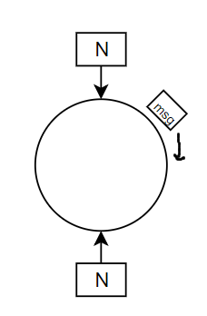

* logical
* the message is sent thru the ring
* suitable for cities
* how the devices share the media? Message can be lost. solution : **token**

**Bus topology**

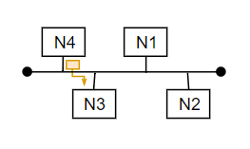

* no token -> **CSMA / CD** : Carrier Sense Media Access / Collision Detection
* Carrier Sense : Listen to the network and speak if only silent
* Collision Detection : If message dropped at the same time, repeat message
* suitable for small networks

**STAR**

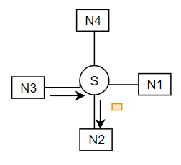

* Same as bus topology with more intelligence
* **using switches** (eg rj45/C5)
* Efficient, reduces collisions, but there is still some
* Multistack
* Switch can buffer the messages so everyone can talk to each other
* *basis of LAN networks*

Less collision; best performances of the network

### 5/ Classification

Two groups : LAN PAN and MAN RAN WAN

**LAN**

* small network managed by a community
* unique adresses (unique email…)
* may have devices connected to the switches direcly with cables or with wireless devices
* Mbps : mega bits ; 1 byte = 8 bits
* each device has an distinct ip adress

A network share a common part of the IP adress

eg :



10.4 : shared

179.18 : private

Each one of the numbers is a byte : **1<x<255**

Reminder : 1 byte (=octet) is 8 bits

To be connected to internet, you have to go through a **NAT** (network a translator) then an **ISP** (Bouygues…)

Internet : huge network of routers

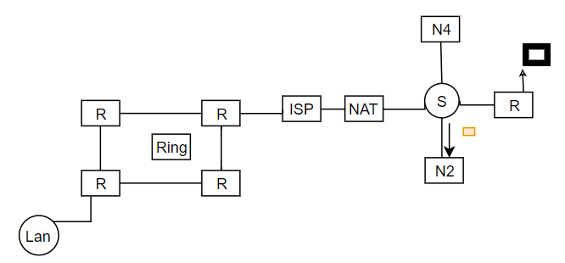

6/ Networks peripherals

* **Hub** 
  + physical connector
  + broadcast the information to all the devices (no intelligence)
  + main prob : collisions
  + popular when switches were expensive. Nowadays, none uses hubs
  + when it gets a msg, it sends it back
* **router** 
  + used mainly outside of lans
  + operates at a network layer

# Network software

OSI Model ; **open system interconnection**

* connection model
* 7 layers
  + Apps
  + Presentation
  + Session
  + Transport layer cuts the message into signals and sends it to network. adds src and dest ports
  + Network overhead + src dest @
  + Data Link : overhead + src dest physical (MAC) @
  + Physical layer responsible to transform signals ⇔ 0/1

**TCP/IP**

* don’t need to specify the apps, presentation and session layers => 1. Apps
* 4.Transport => 2. TCP () / UDP (multimedia)
* 3. Network => 3. IP
* Data
* doesn’t tolerate the data loss. So if one piece is lost, all the file is lost; cares about reliability

UDP cares about the date flow not about the loss